[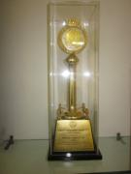](http://www.microlabsltd.com/files/awards/original/5497IMG_0063.jpg)

05th January 2013, Mumbai

**Quality Excellence Gold Award**

Awarded:Micro Labs Baddi Plant

Awarded by:Indian Drug Manufacturers Association (IDMA)

Presented by:

Mr. Sriram Shrinivasan, Partner-Life Sciences, Accenture, India, Mr. Amit Backliwal, General Manager , South Asia, IMS Health, Mr. Manish U Doshi, President,IDMA, Mr. J Sipahimalani, Chairman - Quality Management & Technical, IDMA

[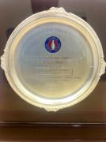](http://www.microlabsltd.com/files/awards/original/15432Goa.JPG)

05th January 2013, Mumabi

**Quality Excellence Silver Award**

Awarded:Micro labs Goa Plant

Awarded by:Indian Drug Manufacturers Association (IDMA)

Presented by:

Mr. Sriram Shrinivasan, Partner-Life Sciences, Accenture, India, Mr. Amit Backliwal, General Manager , South Asia, IMS Health, Mr. Manish U Doshi, President,IDMA, Mr. J Sipahimalani, Chairman - Quality Management & Technical, IDMA

[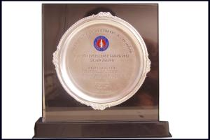](http://www.microlabsltd.com/files/awards/original/12990Eye%20Drops%20Plant.jpg)

05th January 2013, Mumbai

**Quality Excellence Silver Award**

Awarded:Micro Labs Eye Drops Plant

Awarded by:Indian Drug Manufacturers Association (IDMA)

Presented by:

Mr. Sriram Shrinivasan, Partner-Life Sciences, Accenture, India, Mr. Amit Backliwal, General Manager , South Asia, IMS Health, Mr. Manish U Doshi, President,IDMA, Mr. J Sipahimalani, Chairman - Quality Management & Technical, IDMA

[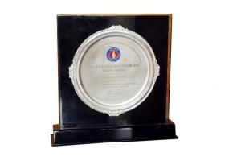](http://www.microlabsltd.com/files/awards/original/27872API.jpg)

05th January 2013, Mumbai

**Quality Excellence Silver Award**

Awarded:Micro Labs API Plant

Awarded by:Indian Drug Manufacturers Association (IDMA)

Presented by:

Mr. Sriram Shrinivasan, Partner-Life Sciences, Accenture, India, Mr. Amit Backliwal, General Manager , South Asia, IMS Health, Mr. Manish U Doshi, President,IDMA, Mr. J Sipahimalani, Chairman - Quality Management & Technical, IDMA

[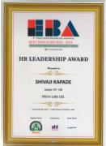](http://www.microlabsltd.com/files/awards/original/17960Award%20certificate.JPG)

21st December 2012, Pune

**HR Leadership Award 2012-13**

Awarded:Mr. Shivaji Kapade, Sr. VP, Human Resource

Awarded by:7th Employer Branding Awards

[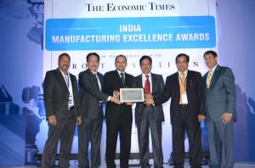](http://www.microlabsltd.com/files/awards/original/3784Baddi%20Gold%20Award.JPG)

14th December 2012, Mumbai

**India Manufacturing Excellence Awards (IMEA) 2012**

Awarded:Micro Labs Baddi Plant

Awarded by:Frost & Sullivan in association with Economic Times

[](http://www.microlabsltd.com/files/awards/original/22810Innovative%20R&D%20Company%20of%20the%20yr%202012.JPG)

21st September 2012, Mumbai

**Innovative R&D Company of the Year 2012**

Awarded:Micro Labs Limited

Awarded by:Pharma Leaders

[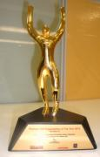](http://www.microlabsltd.com/files/awards/original/29568Pharma%20CSR.JPG)

21st September 2012, Mumbai

**Pharma CSR Organisation of the Year 2012**

Awarded:Micro Labs Limited

Awarded by:Pharma Leaders

[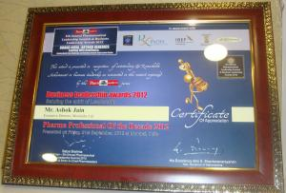](http://www.microlabsltd.com/files/awards/original/6865DSC04411.JPG)

21st September 2012, Mumabi

**Pharma Professional of the Decade**

Awarded:Mr. Ashok Jain, Executive Director

Awarded by:Pharma Leaders

[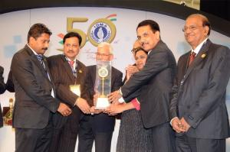](http://www.microlabsltd.com/files/awards/original/1664517273BADDI%201edit.jpg)

06th January 2012, Mumbai

**Quality Excellence Gold Award**

Awarded:Micro Labs Baddi Plant

Awarded by:Indian Drug Manufacturers Association (IDMA)

Presented by:

Shri Rajeev Kher, Additional Secretary, Department of Commerce, Government of India

[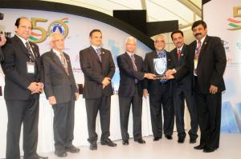](http://www.microlabsltd.com/files/awards/original/1641401630GOA%20AWARD%20Edit.jpg)

06th January 2012, Mumbai

**Quality Excellence Silver Award**

Awarded:Micro Labs Goa Plant

Awarded by:Indian Drug Manufacturers Association (IDMA)

Presented by:

Shri Rajeev Kher, Additional Secretary, Department of Commerce, Government of India

[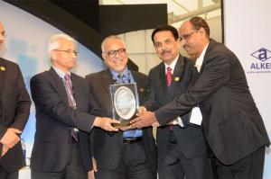](http://www.microlabsltd.com/files/awards/original/1157785201EYE%20DROPS%20AWARD%20edit.jpg)

06th January 2012, Mumabi

**Quality Excellence Silver Award**

Awarded:Micro Labs Eye Drops Plant

Awarded by:Indian Drug Manufacturers Association (IDMA)

Presented by:

Shri Rajeev Kher, Additional Secretary, Department of Commerce, Government of India

[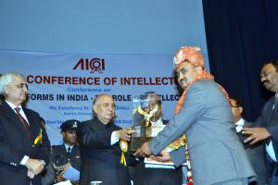](http://www.microlabsltd.com/files/awards/original/296012483Picture%201213.jpg)

23rd December 2011, Bangalore

**The Great Son of Karnataka**

Awarded:Mr. Dilip Surana, CMD, Micro Labs Limited

Awarded by:All India Conference of Intellectuals

Presented by:

Dr. H. R. Bharadwaj, Honble Governor of Karnataka

[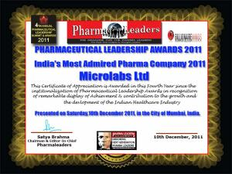](http://www.microlabsltd.com/files/awards/original/1192580531Microlabs%20India%27s%20Most%20Admired%20Pharma%20Company.jpg)

30th November 2011, Mumbai

**Indias Most Admired Pharma Company 2011**

Awarded:Micro labs Limited

Awarded by:Indias Leading bi- monthly pharma magazine and the IACC (Indo- American Chamber of Commerce)

Presented by:

His Excellency Dr.H.R. Bharadwaj, Honble Governor of Karnataka

[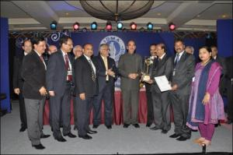](http://www.microlabsltd.com/files/awards/original/16817146751254623190Gold%20Award%20for%20Baddi%20Plant%202009pdf.png)

08th January 2011, Mumbai

**Quality Excellence Gold Award**

Awarded:Micro Labs Baddi Plant

Awarded by:Indian Drug Manufacturers Association (IDMA)

Presented by:

Ghulam Nabi Azad, Union Minister of Health & Family Welfare, Government of India

[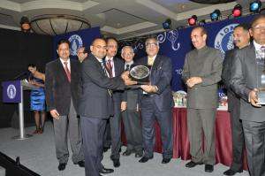](http://www.microlabsltd.com/files/awards/original/15756779511022194687IDMA%202010%20award.jpg)

08th January 2011, Mumbai

**Quality Excellence Silver Award**

Awarded:Micro Labs Goa Plant

Awarded by:Indian Drug Manufacturers Association (IDMA)

Presented by:

Ghulam Nabi Azad, Union Minister of Health & Family Welfare, Government of India

[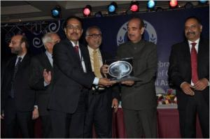](http://www.microlabsltd.com/files/awards/original/10618714961879472902Silver%20Award%20Eye%20Drops.jpg)

08th January 2011, Mumbai

**Quality Excellence Silver Award**

Awarded:Micro Labs Eye Drops Plant

Awarded by:Indian Drug Manufacturers Association (IDMA)

Presented by:

Ghulam Nabi Azad, Union Minister of Health & Family Welfare, Government of India

[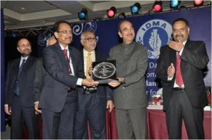](http://www.microlabsltd.com/files/awards/original/13811589577027Silver%20Cephalosporin%20plantpdf.jpg)

08th January 2011, Mumbai

**Quality Excellence Silver Award**

Awarded:Micro Labs Cephalosporin Plant

Awarded by:Indian Drug Manufacturers Association (IDMA)

Presented by:

Ghulam Nabi Azad, Union Minister of Health & Family Welfare, Government of India

[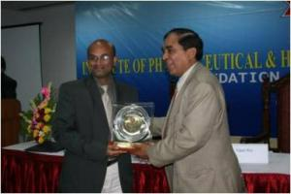](http://www.microlabsltd.com/files/awards/original/1120656810467163151dolo%20awardpdf.jpg)

20th December 2010,

**Best Managed Brand Award**

Awarded:Brand Dolo

Awarded by:Institute of Pharmaceutical Healthcare Management & Researchs conference

Presented by:

Prof. L. K. Maheshwari, Former Vice Chancellor, BITS Pilani

[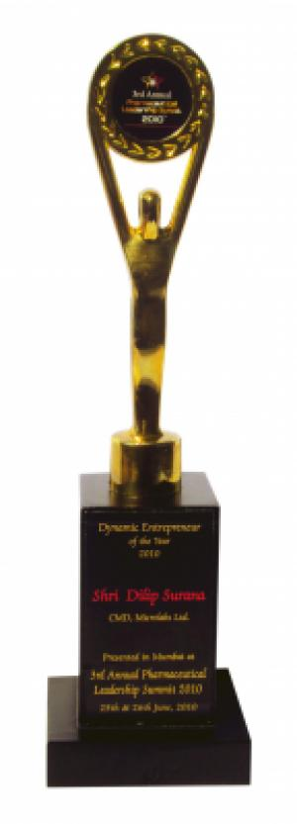](http://www.microlabsltd.com/files/awards/original/1877324090Dynamic%20Enterprenuer%20pdf.jpg)

27th June 2010,

**Dynamic Entrepreneur of the year**

Awarded:Mr. Dilip Surana, CMD, Micro Labs Limited

Awarded by: Pharmaceutical Leadership Summit

[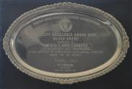](http://www.microlabsltd.com/files/awards/original/1333962243Cephalosporinpdf.jpg)

16th January 2010, Mumbai

**Quality Excellence Silver Award**

Awarded:Micro Labs Cephalosporin Plant

Awarded by:Indian Drug Manufacturers Association (IDMA)

[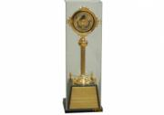](http://www.microlabsltd.com/files/awards/original/6375387315-2.png)

16th January 2010, Mumbai

**Quality Excellence Gold Award**

Awarded:Micro Labs Baddi Plant

Awarded by:Indian Drug Manufacturers Association (IDMA)

[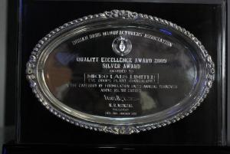](http://www.microlabsltd.com/files/awards/original/167887686IDMA%20award%20trophy%202010.jpg)

16th January 2010, Mumbai

**Quality Excellence Silver Award**

Awarded:Micro Labs Eye Drops Plant

Awarded by:Indian Drug Manufacturers Association (IDMA)

[](http://www.microlabsltd.com/files/awards/original/21030635202056144329Company%20of%20the%20yr08.jpg)

03rd April 2009,

**Company of the Year09**

Awarded:Micro labs Limited

Awarded by:Pharmaceutical Leadership Summit 2009

Presented by:

Shri Ashok Chavan Honble Chief Minister of Maharashtra